Tote System User Guide

WebIntellect Ltd
http://www.webIntellect.co.uk
Contents
List of Figures 3
Introduction 1
Getting Started 1
The Tote screen 2
Screen layout 3
Draw Summary 3
Functions 3
Ticket 4
TO ENTER A BET 4
TO CHANGE A BET 5
TO CANCEL A BET 5
SHORTCUTS 5
HOLD 5
REPEAT 5
PIN 6
CLOSE BETTING 6
Finding the Winning Tickets 6
RE-DRAW 7
ROLLOVER 7
TO EXIT THE SYSTEM 7

Figure 1 Welcome Screen 1
Figure 2 Draw Selection Screen 2
Figure 3 Ticket Screen 2
Figure 4 Draw in Progress Screen 6
Figure 5 Draw Result Screen 7

Introduction
This guide takes you step by step through the Touchtote system. Information is set out in the following order:
Getting started – logging into the system, selecting a tote, description of the tote screen
Entering a bet – how to enter different types of bet
Changing a bet – how to correct mistakes before issuing a ticket
Cancelling a bet – how to void tickets after they have been issued
Shortcuts – features of the system to make entering bets quicker
Closing betting
Closing the machine down

Getting Started
Welcome screen. When you switch the machine on the welcome screen appears. This contains a username box, a password box and an alphabet. In order to access the Tote system you must first log in.
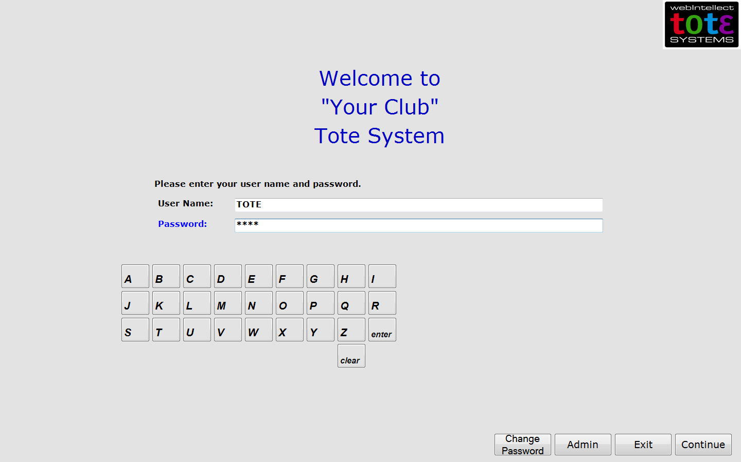
Figure 1 Welcome Screen

Touchscreen users: touch the username line then use the on-screen alphabet to enter your username. Touch the password and enter your password in the same way. Press Continue to move to the next screen.
Keyboard users:Use the letter keys on your keyboard to type in your username, and the down arrow to move to the password line. Once you have typed in your password, click on OK, and the next screen will appear.
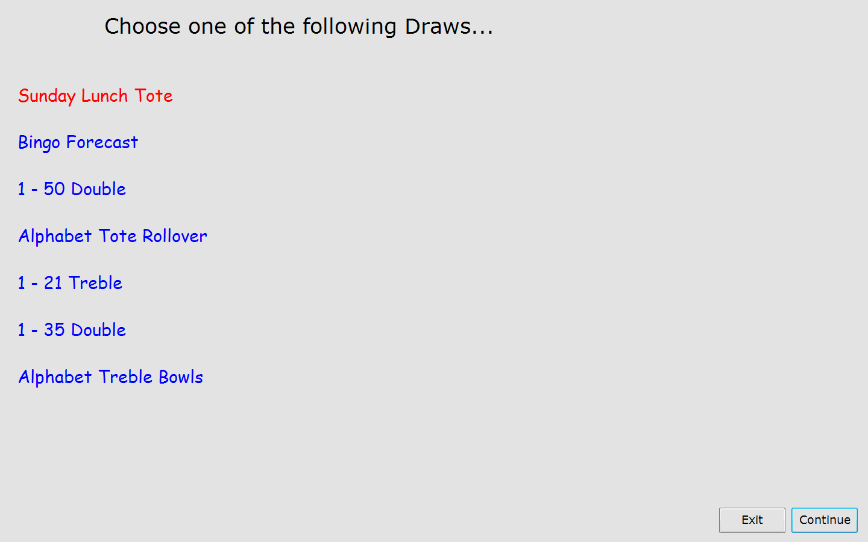
Figure 2 Draw Selection Screen

The screen that appears shows each of the totes used in the club. Touchscreen users: press the one you want to select. Keyboard users: use the arrow keys until the one you want to open appears highlighted in red on the screen. Press OK.

The Tote screen
At the top of the screen is the title of the draw in this case ‘Sunday Lunch Tote’. The current time is displayed to the right hand side. Below these the screen contains three main areas: Draw Summary, Functions, and Ticket.
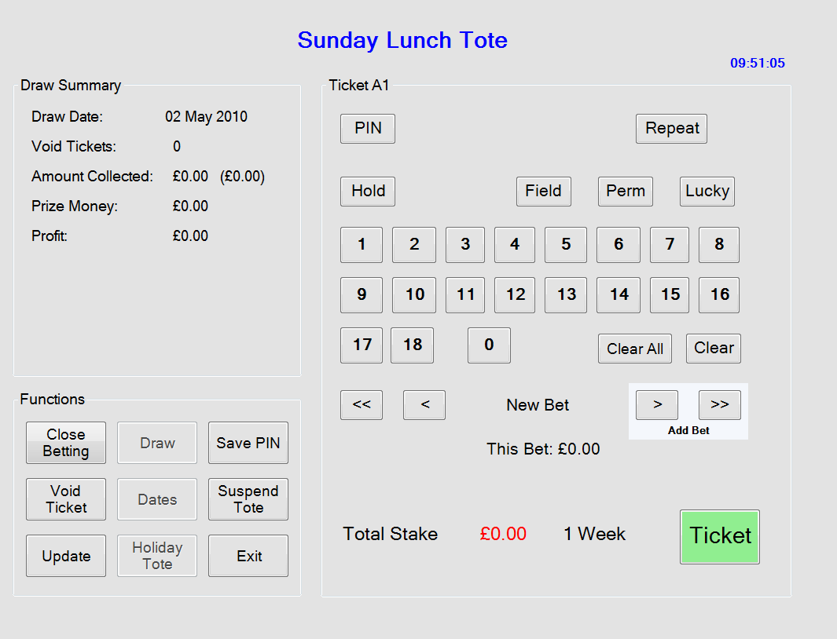
Figure 3 Ticket Screen

Screen layout
Both the touchscreen and keyboard versions of the Touchtote system are identical, and show the same screen. Keyboard users will find that each of the buttons in the Functions box, the buttons at the top of the Ticket box, as well as the arrow keys are on the right hand side of their keyboard (and are not activated on screen). For both types of user the arrow keys can be used to bring up bets already entered back on to the screen and, where appropriate, the left arrow is used for CANCEL, and the right arrow for OK. For keyboard users there are also OK and cancel keys; these are needed when working with dialogue boxes.

Draw Summary
Contains information about the draw and automatically updates as you enter bets.
- Draw Date:- the date the draw can be made,
- Void Tickets:- the number of tickets that have been voided
- Amount Collected:- the total amount of money that has been collected for this draw
- Prize money:- the amount of prize money available
- Profit: - the amount of profit the club will receive.
If the draw type is a Rollover then it will also display:-
- From Previous draws:- the amount rolled over from previous draws
- For Subsequent draws:- the amount of money collected from tickets sold on future draws
And if expenses are to be deducted
- Expenses: - the amount of expenses to be deducted from takings before Prize and Profit monies are calculated.

Functions
Each of the functions is described below and explained in more detail in the following paragraphs.
- Close Betting: - This button will close the betting, the system will now not accept any further for this draw, it will not issue any more tickets. A close of betting receipt will be printed detailing all the information in the draw summary box and date and exact time that betting was closed.
- Draw: - Press this to initiate the actual draw.
- Save PIN: - a PIN is a Punt Identification Number, i.e. a number that uniquely identifies a series of bets. If a customer wishes to place the same series of bets in subsequent draws then you can use the assigned PIN to retrieve those bets easily.
- Void Ticket: - If a mistake is made producing the ticket then it can be marked as void.
- Dates: - Use this to enter the same bets for several draws, e.g. if the customer is going away on holiday for instance you can enter their bet for the next three weeks.
- Suspend Tote:- use this function if you will be away from the machine for any period of time. The system will be locked; a password is required to unlock it.
- Update: - Use this to update the display, If you are using several machines for a tote then it will update the display to show information from all computers. The Amount taken will display Amount Collected: £100.00 (£250.00). Showing that £100.00 has been collected on this machine and £150.00 has been collected on the other machines, giving a total of £250.00 collected. All the other values in the summary box will also update to reflect the new value.
- Holiday Tote: - If enabled pops up a small screen that accepts simple bets for a special draw that is designed to run over several weeks and not interfere with the current draw.
- Exit: - exits the system.

Ticket
At the top of this box you will see, for example, Ticket A1. This uniquely identifies this ticket for any draw. The letter is the machine ID. Each machine in your club is assigned a different letter. The number is the individual ticket number. Therefore, before any tickets for a draw have been sold on machine B, for example, the code B1 appears at the top of the box.
The centre of the screen contains either a set of numbers or an alphabet, depending on which draw you have selected. Touchscreen users will use this directly to enter bets. Keyboard users will find that their keyboard combines both numbers 1 – 90, and an alphabet. For both types of user, as you enter bets, the numbers or letters you select are highlighted in red on the screen.
The upper part of the ticket box contains a series of buttons; the first three of these are PIN, REPEAT, and HOLD. These are the shortcut keys, and are explained in the Shortcuts section below. FIELD, PERM, and LUCKY DIP are explained in the next section – How to enter a bet.
The lower part of the screen contains two buttons – CLEAR and CLEAR ALL. These are explained in the section To change a bet. The arrow and ADD BET keys are explained in the next section – To enter a bet.
NEW BET and THIS BET: A ticket may contain as many bets as a customer wishes to make. NEW BET shows which one of the set of bets is being shown on screen. THIS BET shows the price of the bet that is on the screen.
TOTAL STAKE: As bets are added to the ticket this gives a running total of the price of the bets made. Next to this is shown the period of time betting is open for (e.g. 1 week).
TICKET: Press this (or the TICKET key on the keyboard) to print a ticket.

TO ENTER A BET
Most totes allow different types of bets to be made. To explain how to enter different types of bet we work through an example here or the 1 – 18 Treble.
Key in one number – the system will accept this as a bet only if you select FIELD then ADD BET.
Two numbers – the system will accept this as a bet only if you select FIELD then ADD BET.
Three numbers – this is a single bet and can be placed by pressing ADD BET.
Four numbers and above – the system automatically reads this as a perm and charges accordingly when you press ADD BET.
LUCKY DIP – this is a five-number perm. To get a LUCKY DIP press this key, then ADD BET.
Then: Continue to add that customer’s bets by repeating this procedure.
Finally: When all of a customer’s bets have been entered, press Ticket.
Now a ticket is printed for the customer, and the information in the Draw Summary box on your screen is updated.
The Touchtote system works in a similar way for all other types of tote.

TO CHANGE A BET
To remove the bet currently showing on the screen: press CLEAR (BET).
After the bet is added: Press the back arrow until the bet you want to remove appears on screen. Then press CLEAR (BET).
To clear all bets on a single ticket: press CLEAR ALL. If several bets have been entered, a dialogue box will appear asking you to confirm if you want to cancel all bets. Press OK to do so. All the bets made on that ticket are then cancelled.

TO CANCEL A BET
Press the VOID button. A dialogue box appears on the screen. The machine ID box already shows the ID of your machine. Simply key in the ticket number. This will appear in the Ticket No. Box. Then press Ticket. The system will then automatically complete the details in the remaining boxes. Check that these details are the same as the ones printed on the ticket, then press VOID. The message “Ticket is now VOID” will appear in the dialogue box. Press cancel to remove the dialogue box from the screen. The “Void Tickets” line in the draw summary box is automatically updated.
To cancel the VOID procedure: If you wish to halt the VOID procedure before it is completed, simply press cancel and the VOID dialogue box will disappear from the screen. Once the VOID procedure is completed, however, it cannot be reversed. This is for security purposes.
To void a ticket issued by another machine: To void a ticket issued by another machine enter both the ticket letter and the ticket number in the VOID dialogue box. To change the Machine ID letter use the arrow keys on the keyboard. Then complete the process as explained above.

SHORTCUTS

HOLD
Use this function when a customer places a series of bets where certain numbers are used repeatedly. For example, in a 1 – 18 Treble, a customer wants to place the bets 1-2-3, 1-2-4, 1-2-5.
Key in the repeated numbers 1 and 2. Press HOLD. Key in the third number (3), then ADD BET. Now the first two numbers remain highlighted on the screen. Now type in the third number of the next bet (4), and ADD BET, and so on, until all bets have been entered. Press HOLD again to remove this function.

REPEAT
If a customer wants to place the same bet for a draw more than once, simply press the Repeat key and the last entered bet is placed again.
PIN (Punt Identification Number)
Some customers prefer to place the same bets every week. The Touchtote system has a built-in function that makes this very easy to do both for you and for the customer. When you have entered a set of bets for a customer, ask them if they would like a PIN for it.

To create a PIN
Once all bets have been added, press SAVE PIN. A dialogue box appears asking you to confirm if you want to create a PIN. Press OK to do so, or cancel to remove it. Press Ticket, and the PIN is then shown on the ticket.

To place a bet using a PIN.
Press PIN, then key in the punt identification number. To do so use only the digits 0 – 9. The number appears in blue at the top of the screen. Press Add Bet and the price appears as usual beside Total Stake. Then press Ticket.

CLOSE BETTING
When you want to close the betting on a particular draw, press the CLOSE BETTING key. Press OK to confirm this, or cancel to exit. The message “Betting Has Closed” now appears at the top of the screen. A ticket is now printed showing the information that is in the DRAW SUMMARY box.

Finding the Winning Tickets
After the draw has taken place, press DRAW. The “Draw in Progress” screen now appears. You must now enter the winning numbers on to this screen.
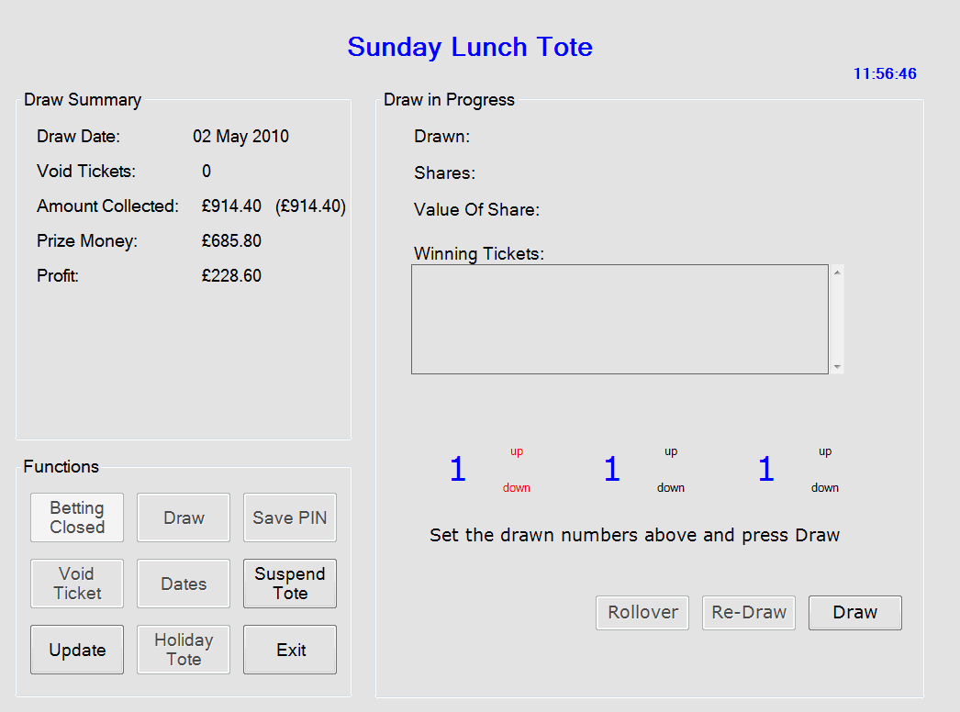
Figure 4 Draw in Progress Screen

Touchscreen users- “up” and “down” appear highlighted in red next to the first number. Press these to obtain the first winning number. Then press the second number, and the up/down highlighting will move to that number. Enter that number in the same way, then move to the third, and so on.
Keyboard users – use the up and down arrows to select the first winning number, then the right arrow to move to the second. Use up and down arrows again to select the second winning number, then move to the third, and so on.
When the winning numbers have been entered, press DRAW again. A dialogue box appears asking you to confirm if the numbers you entered are correct. Press OK to confirm, or Cancel to return to the previous screen. There now appears on the screen the date of the draw, the number of shares, the value of each share, and the numbers of the winning tickets.
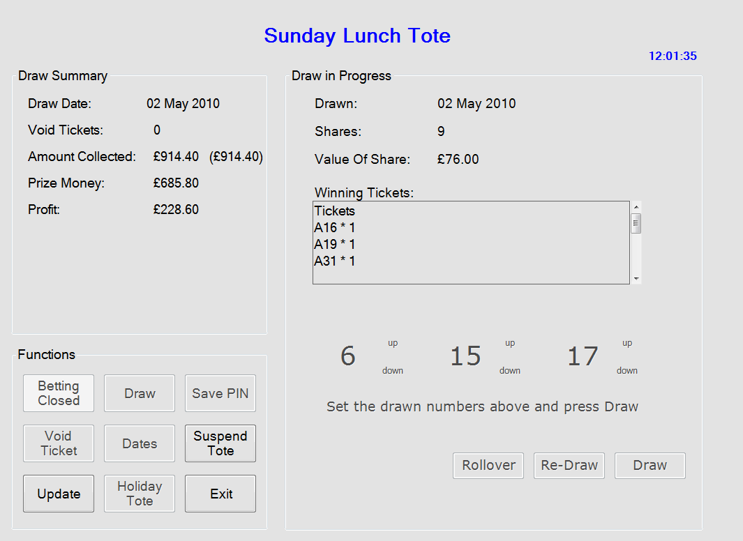
Figure 5 Draw Result Screen

Note that if there are several shares you will have to scroll down through the “Winning Tickets” box to see all of them. Use the up/down arrow keys to do this. The above example shows that there are nine winners each to receive £76.00. A draw result slip will now be printed showing the results of the draw. The printed receipt will show 9 shares at £76.00 (actual value of each share rounded down to nearest 50p) and a club profit of £230.40 which is the available profit as shown on screen plus £1.80 (9 * 20p).
If there are no winning tickets then press re-draw to repeat the draw process. If the draw is configured as a rollover the re-draw button is disabled, press rollover and amount of profit and rollover are calculated and printed.

RE-DRAW
Press RE-DRAW, and the first “Draw in Progress” screen reappears. Once the new draw has taken place, enter the new winning numbers as described above.

ROLLOVER
If the draw is to roll over, press ROLLOVER. The Draw Summary box is now updated with the date of the next draw.

TO EXIT THE SYSTEM
Touchscreen users – press EXIT
Keyboard users – press CANCEL
A dialogue box appears asking if you to confirm if you want to quit. Press OK to confirm, or Cancel to return to the previous screen. The WELCOME screen now reappears. To shut either press EXIT or CANCEL, as before. A dialogue box appears again asking you to confirm. Press OK to complete the system shutdown.

